**3Laboratory 07**: L & C Circuits: Filters and Energy Revisited

(Edit this document as needed)

Partner 1: __________John Gonzalez_____________________

Partner 2: __________Saaif Ahmed_____________________

*Part A*

(The material from part A should be available from your Laboratory 5 results. If you already have the plots, you can include them here rather than make new plots.)

Brief description of LC experiment:

The LC experiment will aim to visualize the oscillation between an Inductor and Capacitor when placed in parallel with each other and to observe how the energy between them decay over time.

Excel plot of experimental data (Discovery Board results) for decaying sinusoidal voltage for the LC circuit, with annotations.

Oscillation frequency (in Hertz)

|  |  |
| --- | --- |
| f | 5032 Hz |

LTSpice plot of decaying sinusoidal voltage for the LC circuit, with annotations.

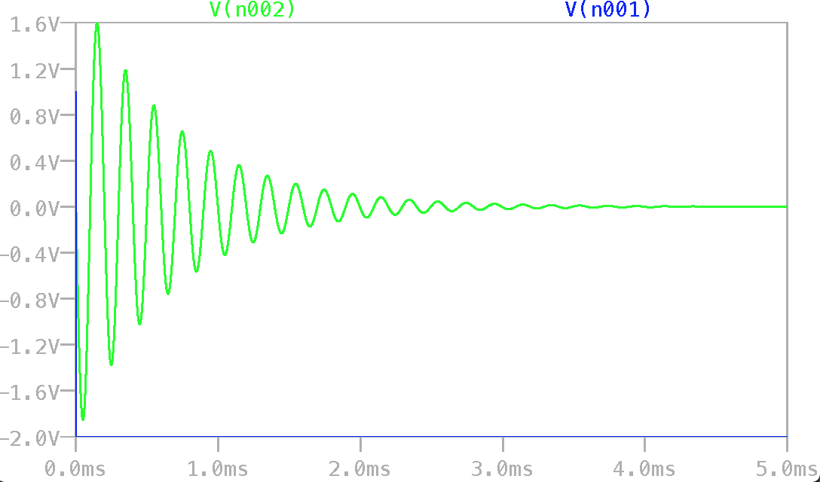

Blue- Source Voltage

Green- Load Voltage

Excel plots of energy stored in the capacitor and energy stored in the inductor, with annotations.

Max energy of Inductor

How does the energy stored change with time for each device?

The energy in the Inductor stars out high and oscillates over time with dampening and eventually reaches zero after a very long time. The energy in the Capacitor starts out at 0 and reaches a higher value and oscillates down to 0 with dampening after a very long time.

What can you say about the way the energy changes with time with regard to the two devices? On the plot, indicate when the capacitor has most of the energy and when the inductor has most of the energy.

The two devices see energy changes that approach or start at a high value but then dampen and oscillate to very low values for a very long time.

*Part B*

Brief description of filter experiment:

Determine how the components (inductor/capacitor) operate in a range of different frequencies, and to observe how they filter a circuit.

Plot of input and output voltages for the RC circuit with a 10Hz source, including annotations.



Plot of input and output voltages for the RC circuit with a 10kHz source, including annotations.



Verification of circuit/results: TA/Instructor’s initials _______HC_______________

Based on your observations your 10Hz and 10kHz output voltages, is the RC circuit a Lowpass filter (LPF) or a Highpass filter (HPF)?

The circuit was a low pass filter.

If R and C were flipped, what kind of filter did you build, LPF or HPF?

High Pass filter

Calculation of the corner frequency for the RC circuit.

|  |  |
| --- | --- |
| fc | 159 Hz |

Plot of input and output voltages for the RC circuit at the corner frequency, including annotations.



LTSpice plots of frequency sweep for the RC circuit. On the plot identify the frequencies investigated previously (10Hz, cutoff frequency, 10kHz).

10kHz

159Hz

10Hz

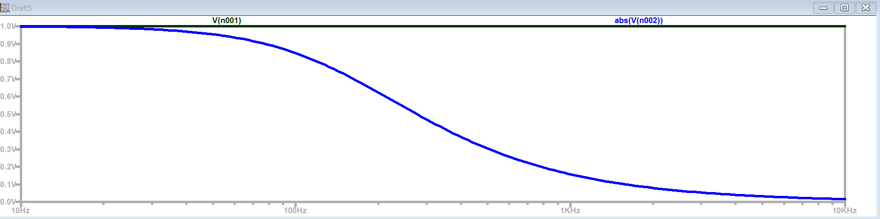

For what range of frequencies is the output amplitude approximately equal to the input amplitude?

10-30Hz

For what range of frequencies is the output amplitude close to zero?

3kHz-10kHz

Which of the above frequency ranges corresponds to the capacitor acting like a short circuit (zero resistance)?

3kHz-10kHz

Which of the above frequency ranges corresponds to the capacitor acting like an open circuit (infinite resistance)?

10-30Hz

Verification of circuit/results: TA/Instructor’s initials ___________YL_________

Fill in the following table, indicating whether the component acts like a short circuit or an open circuit at the indicated frequencies.

|  |  |  |
| --- | --- | --- |
| Circuit Component | Low Frequencies | High Frequencies |
| Capacitor | Open | Short |
| Inductor (Ideal) | Short | Open |
| Inductor (Practical) | Small Resistor | Open Circuit |

Identify the type of filter (LPF or HPF) represented by the following circuit configurations.



Circuit #1= Low Pass Filter

Circuit #2 =High Pass Filter

Circuit #3= Low Pass Filter

Circuit #4= High Pass Filter

Draw the schematic for the Figure A-1 (refer to the pdf for the experiment) when the source is DC (low frequency). Identify the voltage level just prior to the start of oscillation.

1. LPF, 2- HPF, 3- LPF, 4- HPF

Oscillator voltage before oscillation will be 2V

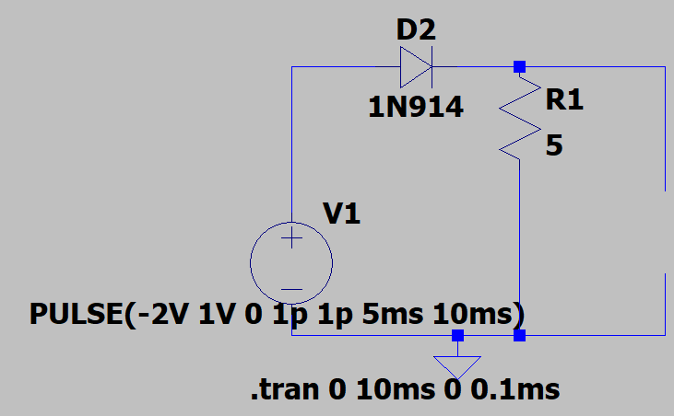

Using Ohm’s law, determine the current through the resistor (effectively through the inductor) just before oscillations starts.

|  |  |
| --- | --- |
| IR | 0mA |

Determine the energy stored in the inductor and the energy stored in the capacitor.

|  |  |
| --- | --- |
| WC (capacitor energy) | 2*10^-6J |
| WL (inductor energy) | 0J |

At the start of oscillation, which component stores the most energy just before oscillation starts?

The capacitor stores the most energy just before the oscillation starts.